The Identify Complex Confluence tool provided in the STARS toolset creates a text file containing the pointID for all complex nodes in the LSN. A complex node occurs when the downstream nodes of three or more edges converge and flow into a single downstream edge. Although these nodes are not considered a topological error in the geographic information system (GIS) or in the LSN, they are not permitted in the SSN Object. Therefore, each error must be manually edited. The following instructions were put together by Dona Horan, at the US Forest Service Rocky Mountain Research Station, to help users manually remove complex confluences.

Create a shapefile of complex confluences

- In ArcMap, add the streams shapefile that was used to create the LSN (don’t use edges) and the node feature class from the LSN.

- In ArcMap, open the nodes attribute table and select all of the complex nodes using the pointID values listed in the text file created by the Identify Complex Confluences tool. To do this:
  - Open the .txt file created by the Identify Complex Confluences tool in Notepad (or some other text editor).
  - Delete the first comma preceding the first number at the beginning of the file and the last comma at the end of the file. Select and copy all of the remaining text.
  - In ArcMap, open the nodes attribute table and select all of the complex nodes using the following query:

[pointid]in(paste pointids from text file here)

For example, if nodes with pointid values = 15 and 16 are complex confluences, the query would look like this:

[pointid]in(15,16)

  - Once the complex confluences have been selected, export the selection and name it “ComplexConfl.shp”

Correct the complex confluences:

- Change the symbol of the stream lines to “Arrow at End”
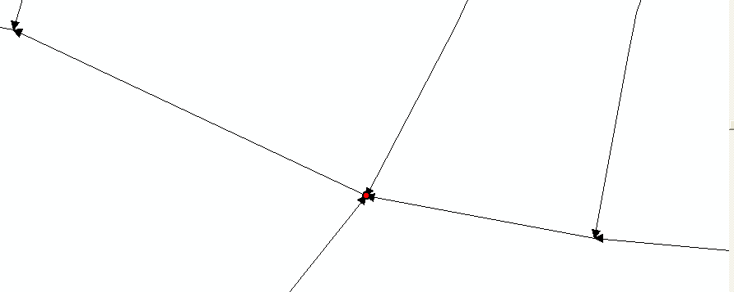

- Click on the Editor tool bar, select Start Editing, and set options as follows:
- Editor > Options
    - Snapping tolerance: 10 map units (or a more suitable tolerance for your data)
    - Check “Show snap tips”
    - Click OK
- Editor > Snapping. This will open the Snapping Environment dialog box.
- Check the “End” box next to the stream layer

Fix image – clearer and Complex confl.
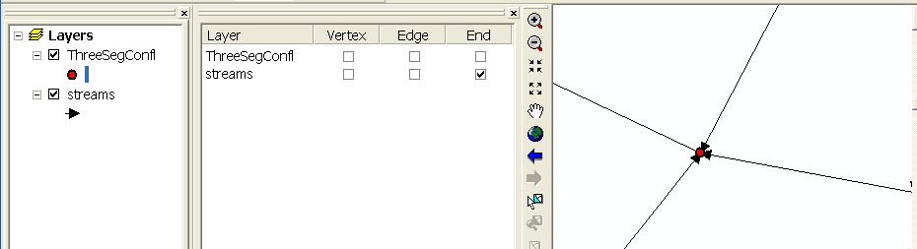

- Start editing
  - Click the Edit tool (black arrow on the editing toolbar) and select the stream segment that you want to split.
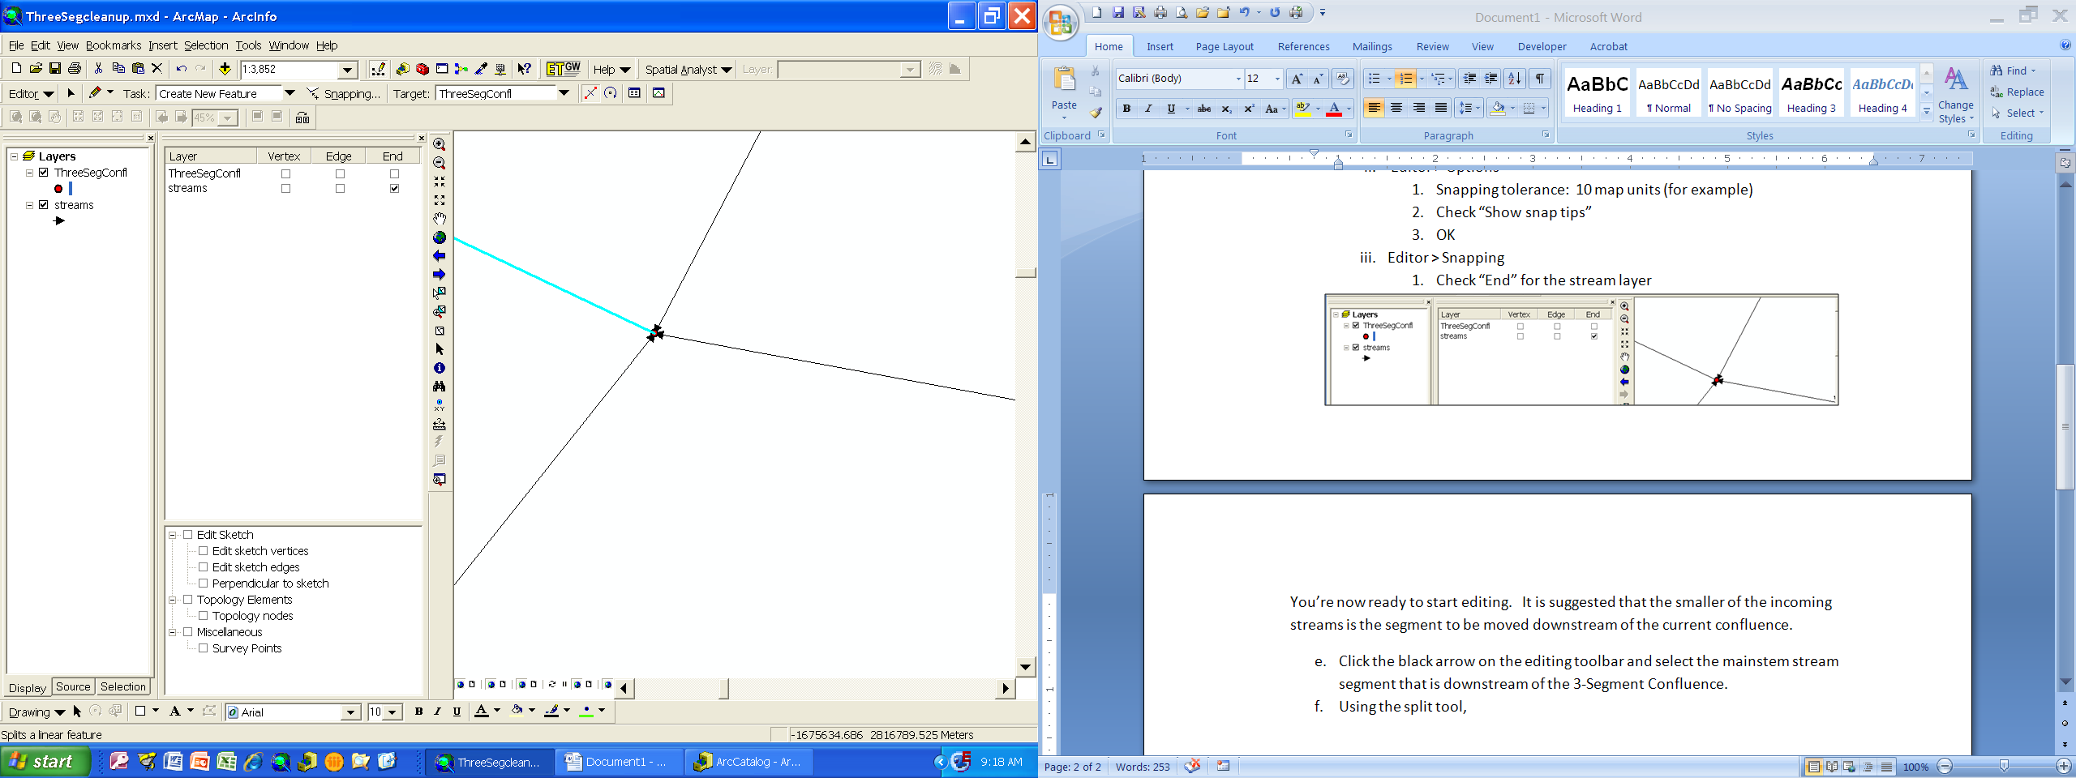
Split Tool

  - Click on the Split tool, identify the location where you would like to split the selected segment, and then click once at that location. A downstream arrow will appear and the split site. If the segment has been successfully split, a downstream arrow will appear at the split.
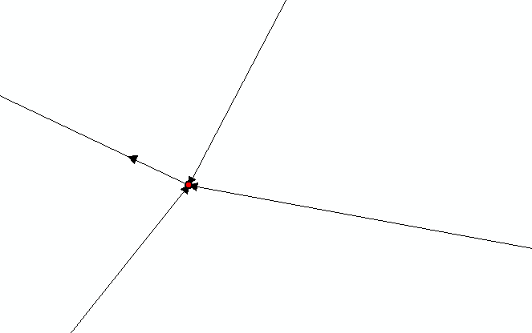

  - Select the stream that is to be relocated. On the editor toolbar, change Task: to Modify Feature. Place cursor over the node at the confluence and press and hold the left mouse button. The symbol of the cursor will change from a black pointer to a red and black symbol:

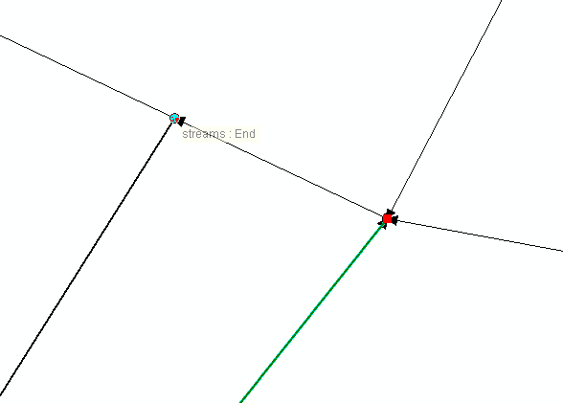
  - Drag the highlighted stream node to the location where the segment was split in step b. This location is easy to locate because of the arrow at the end of each segment. When the Snapping message “streams: End” appears, release the left mouse button. At this point, the stream will be snapped to the end node at the split point.

  - Choose Clear Selected Features to clear the original stream line.
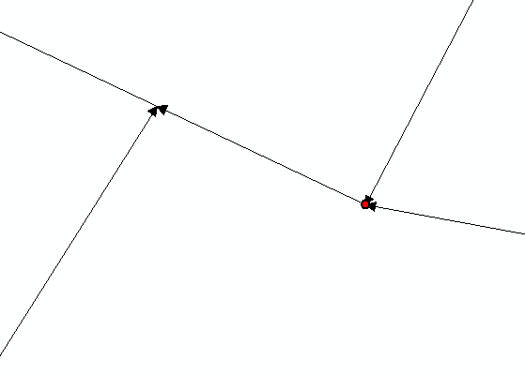

  - Save the edits after each complex confluence is corrected.
  - Once every complex confluence has been fixed, Stop Editing.

- Using ET GeoWizards (http://www.ian-ko.com/ET_GeoWizards/gw_main.htm), clean the stream lines and update the stream length of all of the new segments:
  - ET GeoWizards > Polyline > Clean Polyline Layer > Select polyline layer > choose name for new polyline > Next > OK to keep the default Fuzzy tolerance > Next > select Update length field > Finish
  - Create a new landscape network, re-run the STARS Identify Complex Confluence tool, and verify that there are no complex confluences in the stream layer.

